Camera Shots and Angles
My PBL Project is camera shots and angles. Camera shot is the amount of space that is seen in one shot or frame. Camera shots are used to demonstrate different aspects of a film's setting, characters and themes. As a result, camera shots are very important in shaping meaning in a film.
Extreme close-up  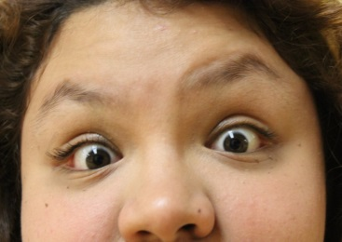 | Medium Shot  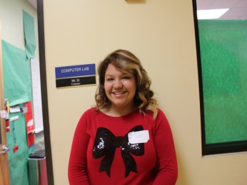
Very Close-up  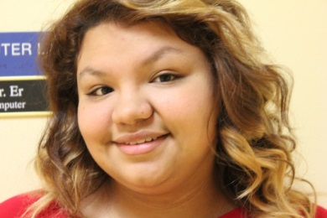 | Medium Long Shot  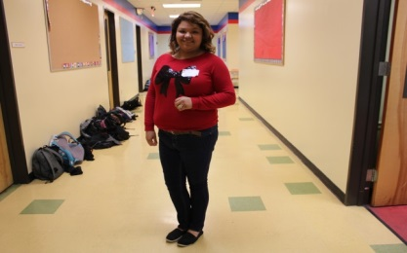
Big Close-up  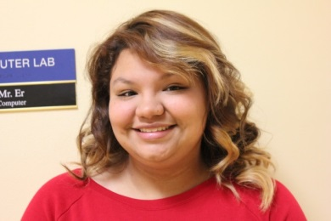 | Long Shot  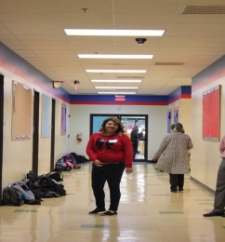
Medium Close-up  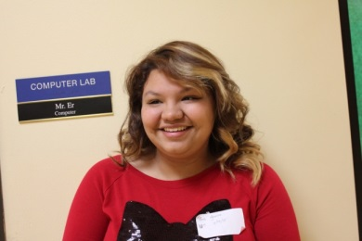 | Extra Long Shot  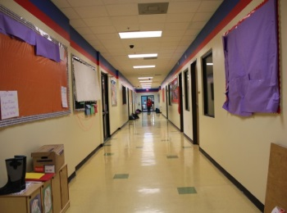

My Video | My Website
